**Faculty Profile s**

1. **Basic Information**

* **Name**: AAKASH SONI
* **Designation**: Assistant Professor
* **Department/School**: Mechanical Engineering
* **Institution Name**: Shri Shankaracharya Institute of Professional Management & Technology, Raipur
* **Email ID**: a.soni@ssipmt.com
* **Contact Number**: 7999592430
* **Photograph**: *(Passport-size, professional)*
* 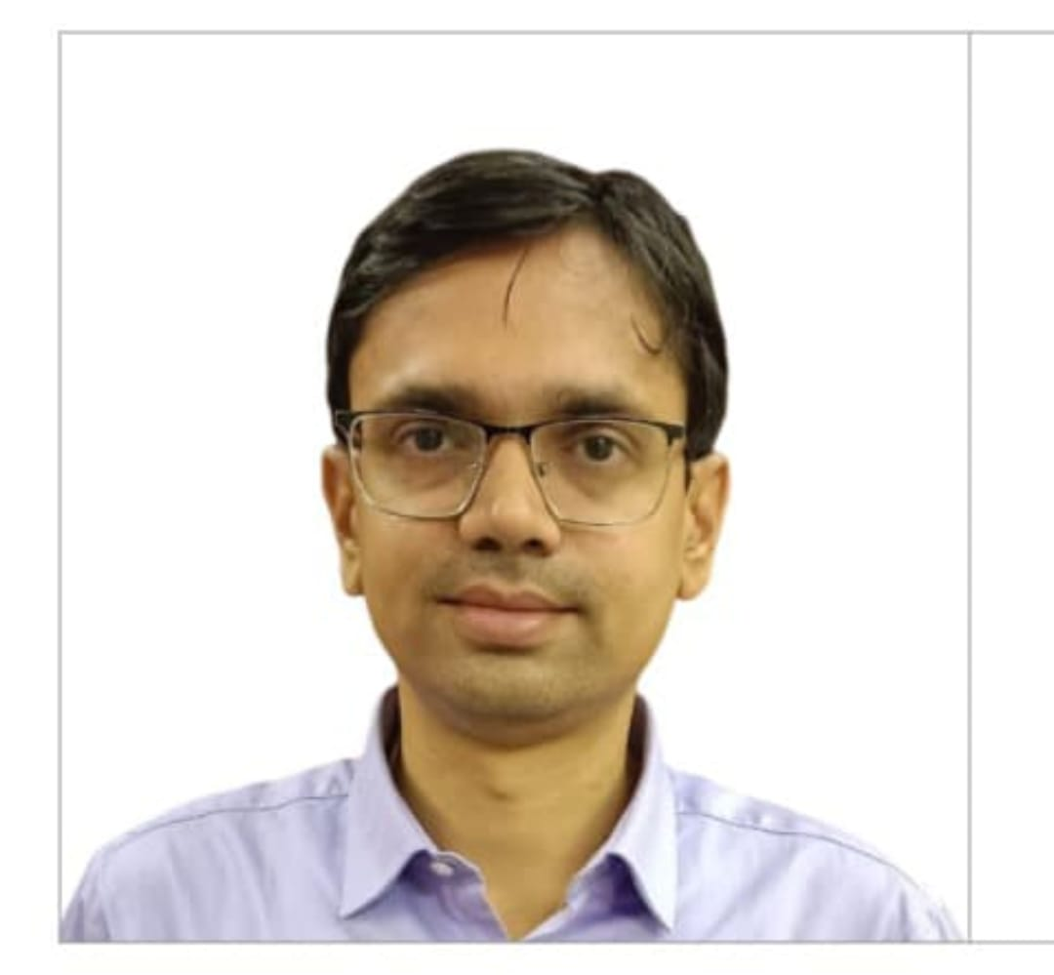

1. **Educational Qualifications**

|  |  |  |  |
| --- | --- | --- | --- |
| **Degree** | **Specialization** | **Institution** | **Year of Completion** |
| UG | Mechanical Engg | RIT, Raipur | 2008 |
| PG | Thermal Engg. | RIT, Raipur | 2014 |
| Ph.D. | Production Engg | GEC, Raipur | Pursuing |
| Others | *(if applicable)* |  |  |

1. **Teaching & Research Experience**

* **Total Teaching Experience**: 16.5 Years
* **Industry Experience**: *(if any)*
* **Research Experience**: Nil

1. **Courses Taught**

* List of key UG/PG courses taught: UG: Kinematics of Machines, Dynamics of Machines, Engineering Mechanics, Product Design and Development, Technology Management

1. **Research Interests / Specialization**

* Key thematic areas or domains of expertise: Industry 5.0

1. **Publications (Last 5 Years)**

* Journals (APA/IEEE format): 02
* Conference Proceedings: 04

1. **Research Guidance**

|  |  |  |
| --- | --- | --- |
| **Level** | **Awarded** | **Ongoing** |
| Ph.D. |  |  |
| PG |  |  |

1. **Awards & Recognitions**

* Institutional / National / International

1. **Administrative Roles**

* Positions held: Head of Department, IIC Convener, IQAC Co-coordinator

1. **Professional Memberships**

* ISTE (Life Member), QCFI (Life Member)

1. **Web Presence**

* Personal academic webpage / Google Scholar / ResearchGate / ORCID

Google Scholar:

ORCID id: 0009-0006-5576-3488

Linkdin: [(25) Feed | LinkedIn](https://www.linkedin.com/feed/)